Congratulations to Rose
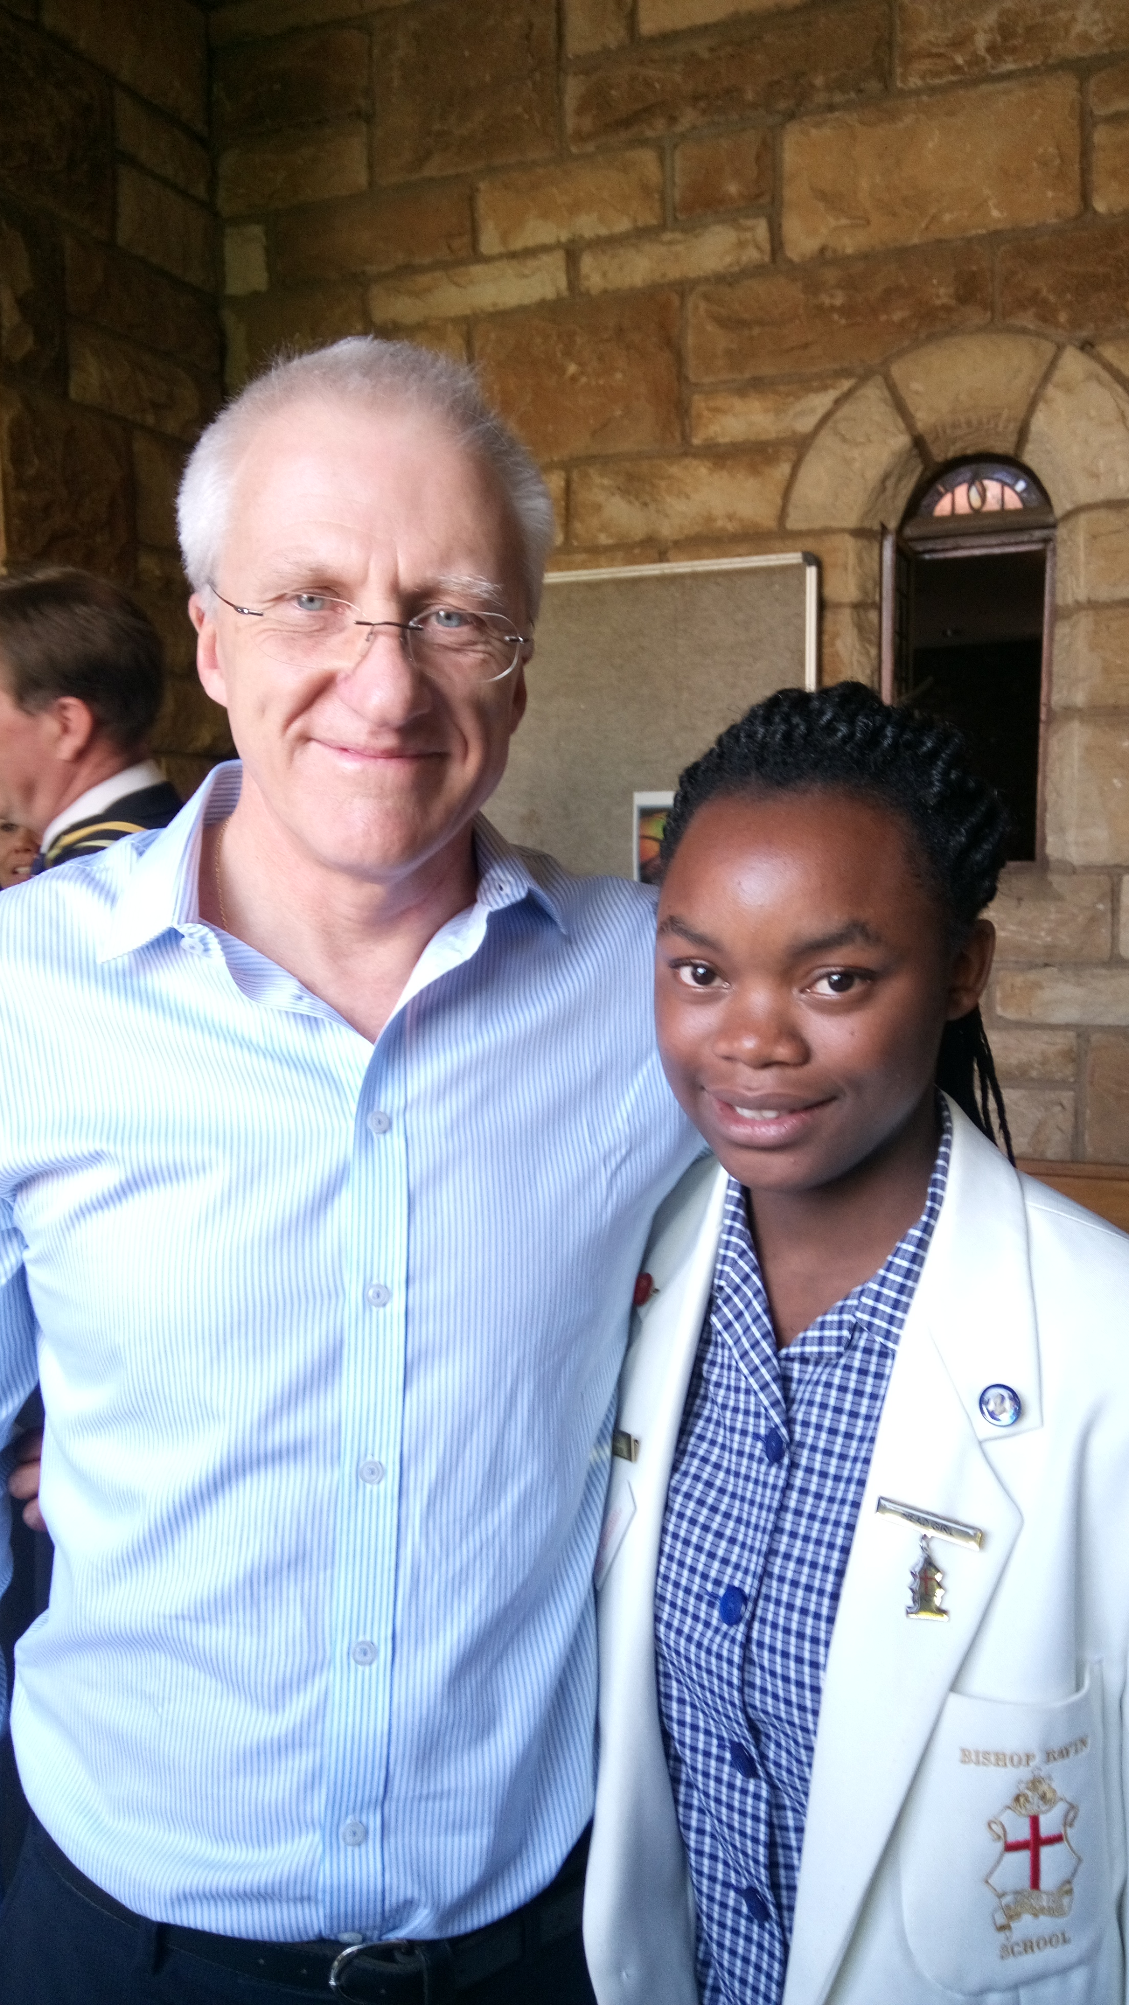
Congratulations to uBambiswano alumna ROSE SHABANGU
who is the 2016 Bishop Bavin head girl!

Mr Dave Morris, Chairman of the St Andrew’s Board of
Directors and member of the uBambiswano Committee,
has sponsored Rose from grade 8 to grade 12 at Bishop Bavin.

We are so proud of this fantastic achievement.

